**The Role of Parent Child Relationship, Birth Order and Type of Family in Moral Development and Emotional Competences among Adolescent**

A Research Proposal Submitted to

**Children’s Research University, Gandhinagar**

**Department of Research Program**

For the Degree of Doctor of Philosophy

in

Psychology

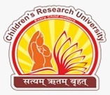

**By**

Nisha R. Chauhan

**Under the Guidance of**

Prof. B. D. Dhila

Professor of Humanities

Department of Research Program

Children’s Research University

Gandhinagar

February, 2025